## Banking App Pt.2

Description:

Apply SQL knowledge to implement a Relational Database into the already constructed banking app.

Requirements:

* Create Oracle 11g database to persist data from banking app
* Use Oracle database to store information pertaining to users and accounts
  + Use sequences for primary keys
  + Use triggers on inserts to increment ids
  + Use triggers to maintain referential integrity on updates and deletes
* Log transaction history in log table on database
  + Include timestamp of logs
* Use OJDBC to connect you Java application with your Oracle database
  + Call at least one stored procedure using JDBC

**TABLES**

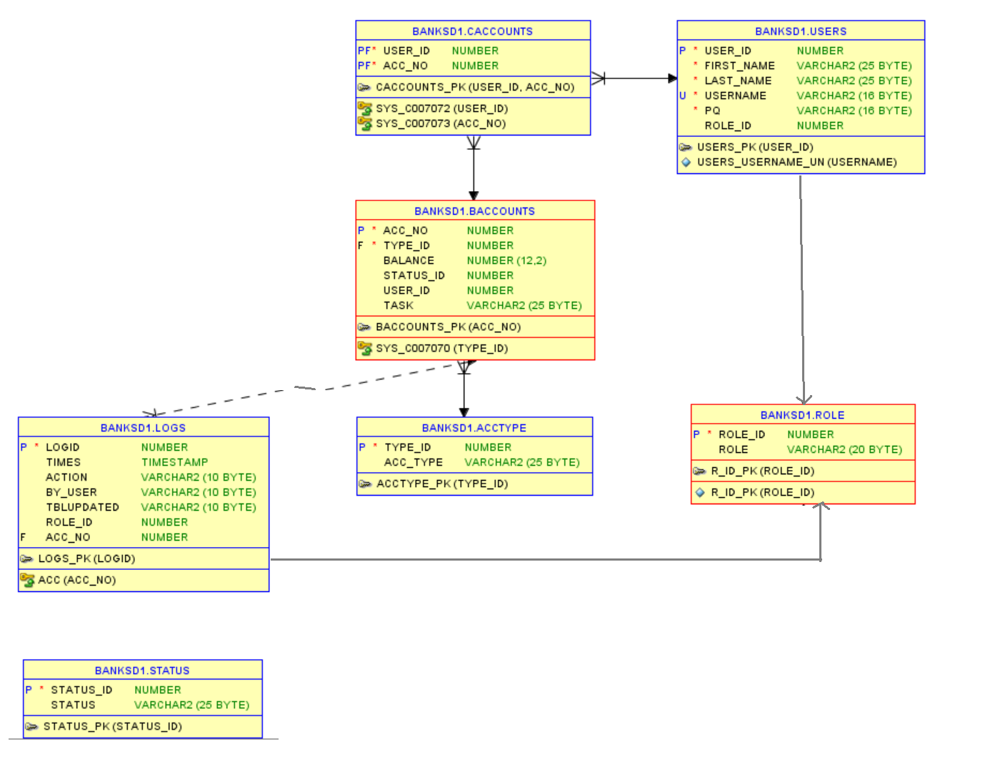

**SEQUENCES**





**TRIGGERS**





**PROCEDURES**

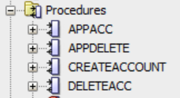

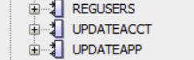

**SNAPSHOT :**

* **LOGS:**

